**Question:**

A new amino acid has been discovered. It has a molecular weight of ~191 and has 4 pKa values: 2.0, 9.5, 11.0, 12.4.

1. Based on what you understand about amino acids, what functional groups do you predict belong to each pKa?
2. Draw a titration curve for the amino acid and indicate the pI(s). Refer to Figure 3-10 as a good example of a titration curve. Obviously you cannot draw the structure of the new amino acid.

**Question:**

The titration curve of a single alanine amino acid shows the ionization of two functional groups with p*K*a values of 2.34 and 9.69. The titration of di-, tri-, and larger oligopeptides of alanine also shows the ionization of only two functional groups, although the experimental p*K*a values are different. The trend in p*K*a values is summarized in the table.

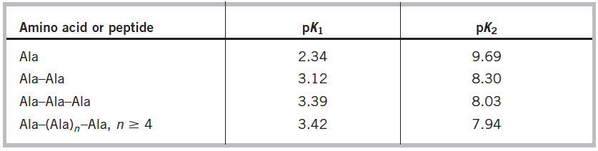

1. Why does the value of p*K*1 *increase* with each additional Ala residue in the Ala oligopeptide?
2. Why does the value of p*K*2 *decrease* with each additional Ala residue in the Ala oligopeptide?
3. Why do the pKa values stop changing after n≥4 alanine residues?

**Question:**

A 100 mL solution of 0.1 M glycine at pH 1.00 was titrated slowly with 10 M NaOH solution. The pH was monitored and the results were plotted as shown in the following graph. The key points in the titration are designated I to V. For each of the statements **below,** *identify* the appropriate key point in the titration curve. The first example answer is given.

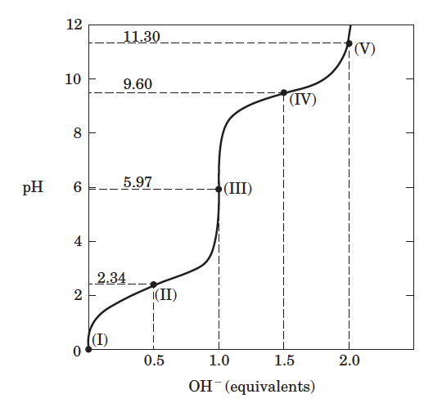

Example question and answer:

**(a)** Glycine is present predominantly as the species +H3NOCH2OCOOH. Answer: Key Point I.

1. The *average* net charge of glycine is zero.
2. Glycine is completely titrated.
3. The predominant species is NH3+CH2COO-.
4. Outside of the beginning and end of titration,this is the *worst* pH region for buffering power.

**Question:**

A. Draw the following tripeptide at pH 1.

Val‐Lys‐Arg

B. In order to bind the tripeptide to a chromatography column, you decide to use a cation exchange column with a pKa of 5. What is the optimal pH range for binding to the column? Why?

C. What is the precise charge of the tripeptide at pH 9.2?

**Question:**

Using UCSF Chimera and the PDB 31VY, identify the possible amino acids that help to position the two phosphates of the NAD+ molecule into the active site. When you look up the PDB on the pdb.org website, you can see what the protein is, so you can decipher it’s position in a specific pathway. Then when you identify the amino acids in the active site, see if you can figure out the mechanism.

1. Hydrolysis of 1 M glucose 6-phosphate catalyzed by glucose 6-phosphatase is 99% complete at equilibrium (i.e., only 1% of the substrate remains). (*R* = 8.315 J/mol·K; *T* = 298 K) What is the Δ*G'*°?
2. From the given information, can we determine Δ*G* under non-standard conditions?

**Question**:

Draw the mechanism for the peptide bond formation in an aqueous environment at physiological pH between alanine and glycine. Assume that H2O is the general acid and OH- is the base.

**Question:** Answer the following about fructose:

1. Draw the structures of the α-anomers of fructose in the pyranose and furanose ring form.
2. How many asymmetric carbons (chiral centers) does each of these structures have?
3. In a solution, which pyranose form would be more favored: α-fructopyranose or β-fructopyranose? Explain your answer.
4. How many stereoisomers of D-fructose are theoretically possible?

**Question:** The compound shown in blue is an epimer of which of the following molecules? Circle the appropriate answer.



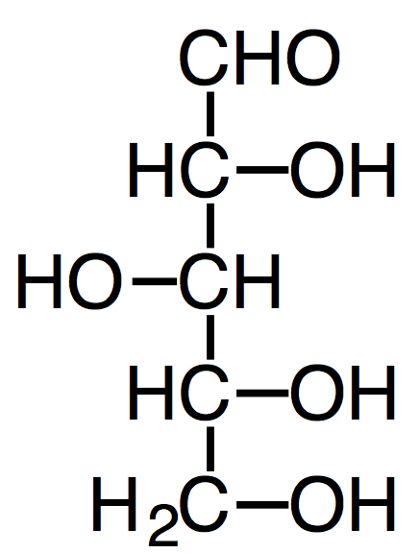 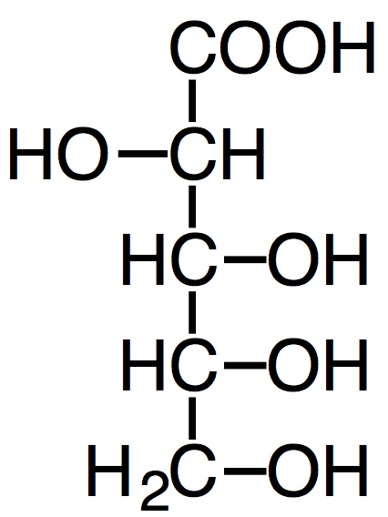 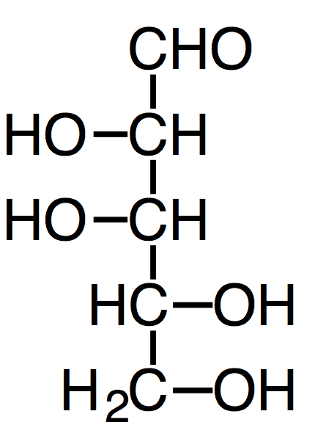  

**Question:** For each statement below, determine of the statement is true or false. Designate true with a “T” or false with an “F” in the blank space given to the left of each statement.

1. Carbohydrates have carbon:hydrogen:oxygen ratio of 2:2:1.
2. A glycosidic link is chemically an ether.
3. Mutarotation between the α- and β- form of a cyclic monosaccharide requires a conformational change.

**Question**: Use the space provided below to answer the following parts of the question. Please note that a new (but related) form of lipid and fatty acid nomenclature is used.

1. Draw fatty acids with the following composition. Number the carbons of each fatty acid:

18:3(Δ9,12,15)cis,cis,cis 17:1(Δ5)cis

1. Which of the two fatty acids shown above would have the lowest melting point? Why?